**Module (HTML) -1**

1. **Are the HTML tags and elements the same thing?**

**Ans: the HTML tags and elements are not same thing.**

**Ex. Tags: <b></b> Elements: <b> content </b>.**

1. **What are tags and attributes in HTML?**

**Ans: Opening Tag: start of an element (e.g.<h1>)**

**Closing Tag: End of an element(e.g</h1)**

**Attributes:**

**E.g. id,class,src,href**

1. **What are void elements in HTML?**

**Ans: No End Tag, No Content, Attributes Only**

**E.g.**

**<!DOCTYPE html>**

**<html lang="en">**

**<head>**

**<meta charset="UTF-8">**

**<meta name="viewport" content="width=device-width, initial-scale=1.0">**

**<title>Document</title>**

**</head>**

**<body>**

**</body>**

**</html>**

1. **What are HTML Entities?**

**Ans:**

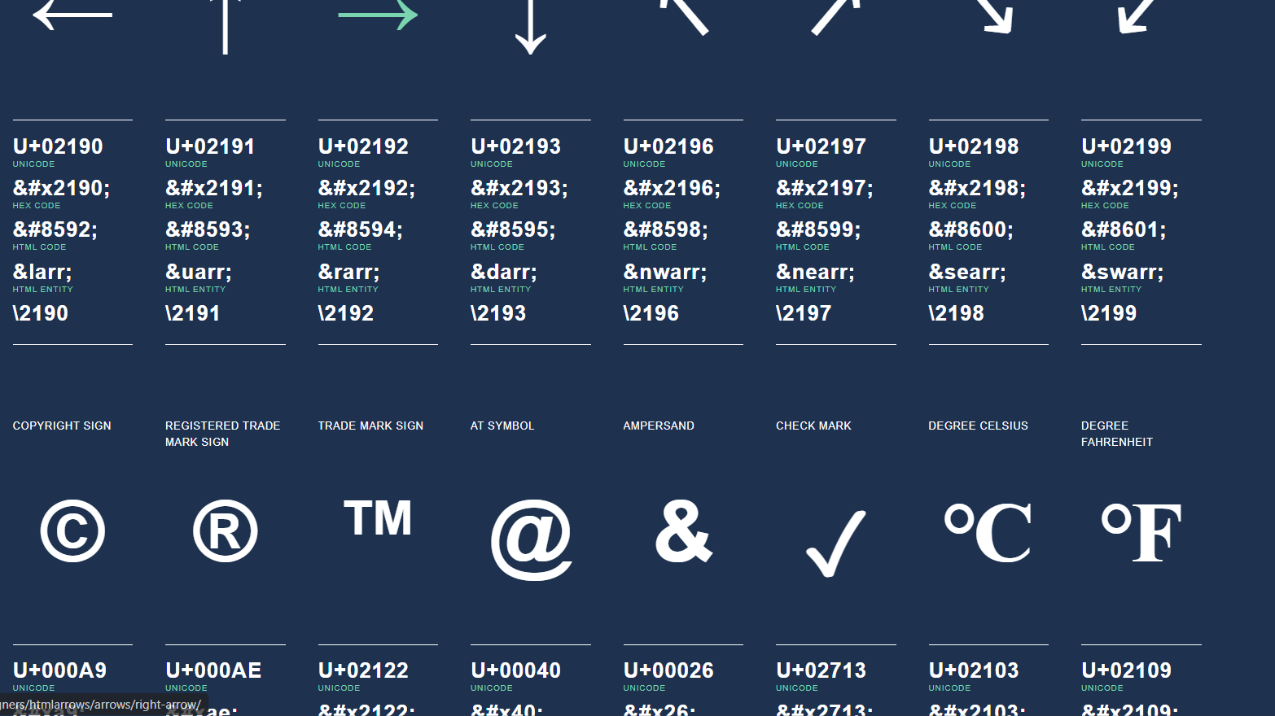

**This photo Shows all Entities .**

1. What are different types of lists in HTML?

Ans: There Are Three Type of Lists.

Li,ul,ol li= list item ol = Ordered list ul=Unordered list.

E.g.

**<!DOCTYPE html>**

**<html lang="en">**

**<head>**

**<meta charset="UTF-8">**

**<meta name="viewport" content="width=device-width, initial-scale=1.0">**

**<title>Document</title>**

**</head>**

**<body>**

**<ul type="circle">**

**<li>menduvada</li>**

**<li>penda</li>**

**<li>vadapav</li>**

**<li>samosa</li>**

**</ul>**

**<ol>Shiv Shakti Hotel</ol>**

**<ul>**

**<ol>Menu**

**<li>Gujarati</li>**

**<li>Sak</li>**

**<li>DalBhat</li>**

**</ol>**

**<ul>**

**<li>South Indian</li>**

**<li>Dhosa</li>**

**<li>menduvada</li>**

**</ul>**

**<ol>**

**<h1>Fruits</h1>**

**<li>Apple</li>**

**<li>Banana</li>**

**<li>Mango</li>**

**<li>chiku</li>**

**</ol>**

**<ul>**

**<h1>Menu</h1>**

**<li>Gujarati</li>**

**<ol type="A">Mexican**

**<li>1</li>**

**<li>2</li>**

**<li>3</li>**

**<li>4</li>**

**</ol>**

**<li>Punjabi</li>**

**<li>South</li>**

**<ol>Chinese</ol>**

**</ul>**

**</body>**

**</html>**

**6)What is the ‘class’ attribute in HTML?**

**Ans:The class attribute in HTML is used to assign one or more class names to an HTML element. This attribute allows for the application of CSS styles and JavaScript functions to specific elements based on their class. By grouping elements with the same class name, you can style or manipulate them collectively without needing to target each one individually.**

**Syntax:<element class="class1 class2 class3">Content</element>**

**7)What is the difference between the ‘id’ attribute and the ‘class’ attribute of HTML elements?**

**Ans: The `id` and `class` attributes in HTML are both used for identifying and styling elements, but they serve different purposes and have distinct characteristics:**

**`id` Attribute: The `id` attribute is meant to be unique within a document. Each element can have only one `id`, and each `id` must be unique to that specific page.**

**2. **Single Element Targeting**: Because an `id` is unique, it is typically used to target a single specific element for CSS styling or JavaScript manipulations.**

**3. **CSS and JavaScript Usage**: In CSS, styles are applied using `#`, e.g., `#myId`. In JavaScript, you can access an element by its `id` using methods like `document.getElementById('myId')`.**

**4. **Fragment Identifiers**: The `id` attribute can be used as a fragment identifier in URLs, allowing users to link directly to a specific part of the page (e.g., `http://example.com/page#myId`).**

**class` Attribute:**

**1. **Reusability**: The `class` attribute can be used on multiple elements within the same document. Multiple elements can share the same class, making it easier to apply the same styling or JavaScript behavior to multiple items.**

**2. **Grouping for Styling**: It’s commonly used to group elements for styling purposes in CSS. You can assign multiple classes to an element (e.g., `<div class="class1 class2">`), allowing for flexible style applications.**

**3. **CSS Usage**: In CSS, styles are applied using a dot (`.`), e.g., `.myClass`. JavaScript can target elements using methods like `document.getElementsByClassName('myClass')` or `document.querySelector('.myClass')`.**

**4. **Dynamic Behavior**: Classes can be added or removed dynamically using JavaScript, which is useful for creating interactive experiences (e.g., toggling classes for animations).**

**### Summary:**

**- Use `id` for uniquely identifying a single element on a page, often for JavaScript manipulation or when a specific style needs to be applied to one element.**

**- Use `class` for applying styles or behaviors to multiple elements, allowing for easier and more consistent styling across the same types of elements.**

**Understanding these differences helps in structuring your HTML for both style and functionality more effectively.**

**8) What are the various formatting tags in HTML?**

**Ans: <b> bold tag</b>**

**<p> paragraph tag</p>**

**<h1>header tag</h1>**

**<Table>table tag</table>**

**Sementic Tag:**

**<b> </b> <strong></strong>**

**<div></div> <article></article>**

**9)** **How is Cell Padding different from Cell Spacing?**

**Cell Padding:Cell padding refers to the space between the content of a cell and the cell's border. It is the inner spacing that creates a gap inside the cell itself.**

**The main purpose of cell padding is to create room around the content inside a cell, which improves readability and aesthetics by ensuring that text or other elements do not touch the edges of the cell.**

**- **HTML/CSS**: In HTML tables, padding can be controlled using the `padding` property in CSS, or with the `cellpadding` attribute in older HTML specifications (though the attribute is now deprecated in favor of CSS).**

**Cell Spacing: Cell spacing refers to the space between the borders of adjacent cells in a table. It is the outer spacing that separates each cell from one another.**

**- The main purpose of cell spacing is to create a visual separation between cells, making it easier for the user to distinguish between different cells in the table.**

**- **HTML/CSS**: In HTML tables, spacing can be controlled using the `border-spacing` property in CSS (for modern use) or with the `cellspacing` attribute in older HTML specifications (also derecated).**

**10) How can we club two or more rows or columns into a single row or column in an HTML table?**

**Ans:**

**<table border="1">**

**<tr>**

**<td rowspan="2">Merged Row</td>**

**<td>Column 1</td>**

**</tr>**

**<tr>**

**<td>Column 2</td>**

**</tr>**

**</table>**

**<table border="1">**

**<tr>**

**<td colspan="2">Merged Column</td>**

**</tr>**

**<tr>**

**<td>Column 1</td>**

**<td>Column 2</td>**

**</tr>**

**</table>**

**11)** **What is the difference between a block-level element and an inline element?**

**Ans: Block-level elements start on a new line and take up the full width available by default (from the left edge to the right edge of their container).**

**E.g. <div>,<p>**

**Inline elements do not start on a new line. They only take up as much width as necessary and sit within the context of surrounding text.**

**E.g.<span>,<a>**

**12)** **How to create a Hyperlink in HTML?**

**Ans: Syntax:<a href="https://www.google.com">Visit Google</a>**

**<a href="https://www.google.com" target="_blank">Visit Google in a new tab</a>**

**13)** **What is the use of an iframe tag?**

**Ans:** **The <iframe> tag in HTML is used to embed another HTML document within the current document. The name "iframe" stands for "inline frame." This tag allows you to include external content such as a web page, video, or other resources directly onto your webpage.**

**E.g.<iframe width="560" height="315" src="https://www.youtube.com/embed/video-id" frameborder="0" allowfullscreen></iframe>**

**14)** **What is the use of a span tag? Explain with example?**

**Ans: span tag use is table row and table column merged. Row merged use to row span and columnspan merged use to**

**Colspan.**

**E.g.**

**<!DOCTYPE html>**

**<html lang="en">**

**<head>**

**<meta charset="UTF-8">**

**<meta name="viewport" content="width=device-width, initial-scale=1.0">**

**<title>Document</title>**

**</head>**

**<body>**

**<table border="3">**

**<caption><i>A test table with merged cells</i></caption>**

**<tr>**

**<th rowspan="2"></th>**

**<th colspan="2">Average</th>**

**<th rowspan="2">Red eyes</th>**

**</tr>**

**<tr>**

**<td >height</td>**

**<td>weight</td>**

**</tr>**

**<tr>**

**<td>Males</td>**

**<td>1.9</td>**

**<td>0.003</td>**

**<td>40%</td>**

**</tr>**

**<tr>**

**<td>Females</td>**

**<td>1.7</td>**

**<td>0.002</td>**

**<td>43%</td>**

**</tr>**

**</table>**

**</body>**

**</html>**

**15)** **How to insert a picture into a background image of a web page?**

**Ans: use to image tag .**

**E.g.<!DOCTYPE html>**

**<html lang="en">**

**<head>**

**<meta charset="UTF-8">**

**<meta name="viewport" content="width=device-width, initial-scale=1.0">**

**<title>Background Image with Picture</title>**

**<link rel="stylesheet" href="styles.css">**

**</head>**

**<body>**

**<div class="background-container">**

**<img src="path/to/your/picture.jpg" alt="Picture" class="picture"/>**

**<h1>Your Content Here</h1>**

**</div>**

**</body>**

**</html>**

**16)** **How are active links different from normal links?**

**Ans: Normal Links: Typically, these links appear as text that is underlined and displayed in a different color (commonly blue) to indicate that they are clickable.**

**Active Links: An active link is a state that a link can have while it is being clicked. It may change appearance (e.g., color, background) to indicate to the user that the link is currently being selected or activated. This visual feedback can help improve user experience.**

**17)** **What are the different tags to separate sections of text?**

**Ans: Header tag: <h1>**

**Paragraph tag: <p>**

**Division tag: <div>**

**Image: <img>**

**List tage: <ul><ol><li>**

**Main tage: <main>**

18) What is SVG?

Ans: SVG is commonly used for icons, illustrations, logos, charts, and other graphics on the web.

19) What is difference between HTML and XHTML?

Ans: HTML (Hypertext Markup Language) and XHTML (Extensible Hypertext Markup Language) are both markup languages used to create and structure content on the web. XHTML is a stricter and more modern standard that enhances HTML with XML rules, while HTML is more lenient and widely used for practical web development.

**HTML**: HTML is more lenient with syntax rules. For example, it allows unclosed tags, case-insensitivity, and certain tags can be omitted.

**XHTML**: XHTML is a stricter version of HTML. It follows XML rules, which means that it requires proper nesting of tags, all tags must be closed, and all attribute names and values must be in lowercase and properly quoted.

**HTML**: HTML documents can use a variety of doctype declarations depending on the version (e.g., HTML5).

**XHTML**: XHTML requires a specific doctype declaration and typically comes in two flavors: XHTML 1.0 and XHTML 1.1, each with their own strictness in terms of syntax and rules.

20) What are logical and physical tags in HTML?

Ans: Logical tags: Logical tags (also referred to as semantic tags) convey meaning about the content they enclose. They describe the role or purpose of the content rather than its appearance. Logical tags help with search engine optimization (SEO) and accessibility.

E.g.<header>,<article>,<section>,<h1>-<h6>

Physical tags: Physical tags (also known as presentational tags) directly affect the styling or visual presentation of the content. These tags specify how content should be displayed, rather than conveying its meaning. While many of these tags are still present in HTML, the trend in modern web development is to use CSS for styling rather than relying on physical tags.

E.g.<b>,<i>,<u>,<center>